Autonomous Coding Agent Using Generative AI
An Internship Project Report
Submitted to the Trainer of
Blackbucks Education Pvt. Ltd.
In partial fulfilment of the requirements for the award of
GEN AI
(Short Term Internship Program – 2026)
By
Gunde Vishnu Vardhan Naidu 2578A05L14
Under the Esteemed Guidance of
Mrs. Madhu Mathi
Trainer of APSSDC
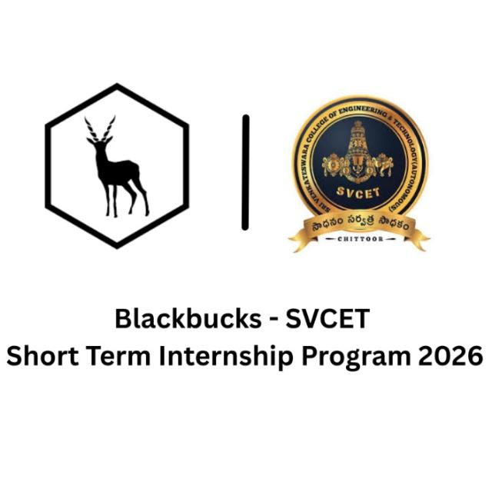
DEPARTMENT OF COMPUTER SCIENCE AND ENGINEERING(B.Tech.)
SRI VENKATESWARA COLLEGE OF ENGINEERING & TECHNOLOGY (AUTONOMOUS)
R.V.S. Nagar, Chittoor-517127,
ANDHRA PADESH
2026

Acknowledgement

I would like to express my sincere gratitude to Blackbucks for providing me with the opportunity to undertake the Generative AI Internship. This internship has provided me with valuable practical experience and enhanced my understanding of modern Artificial Intelligence technologies and software development.
I express my heartfelt thanks to my mentor, Miss. Madhu Mam, for his continuous guidance, encouragement, and technical support throughout the internship. His valuable suggestions and feedback played an important role in the successful completion of my project, "Autonomous Coding Agent Using Generative AI."
I also extend my sincere gratitude to the faculty members and management of Sri Venkateshwara College of Engineering and Technology, Chittoor, for their constant encouragement and support during the internship period.
Finally, I would like to thank my parents, family, and friends for their continuous motivation, patience, and encouragement throughout this journey. Their support inspired me to complete this project successfully.
This internship has been a valuable learning experience that strengthened my technical skills in Python, Generative AI, API integration, and full-stack application development. I sincerely appreciate everyone who contributed to the successful completion of this project.

Abstract

The Autonomous Coding Agent Using Generative AI is an AI-powered application developed to simplify and accelerate the software development process by automating common programming tasks. The project leverages the capabilities of Large Language Models (LLMs) through the Google Gemini API to understand user requirements written in natural language and generate high-quality source code, explain code, detect and fix programming errors, and create technical documentation.
The application features a user-friendly interface built with Streamlit and a robust backend developed using FastAPI. When a user submits a programming prompt, the request is securely processed by the backend and sent to the Gemini API. The AI model analyzes the prompt and generates an appropriate response, which is then displayed through the application interface. The system also maintains chat history and supports additional features such as voice input and voice output to enhance user interaction.
The primary objective of this project is to reduce the time and effort required for coding, debugging, and documentation while improving developer productivity. By integrating Generative AI into the software development workflow, the application assists users in writing cleaner code, understanding complex programming concepts, and producing project documentation more efficiently.
This internship project provided practical experience in designing and developing AI-powered applications using modern technologies such as Python, Streamlit, FastAPI, Google Gemini API, HTML, CSS, JavaScript, Git, and GitHub. It also strengthened skills in API integration, prompt engineering, full-stack development, and the practical implementation of Generative AI solutions.
Overall, the Autonomous Coding Agent Using Generative AI demonstrates how Generative AI can transform software development by making coding faster, more efficient, and more accessible for developers, students, and technology enthusiasts.

Table of Contents

S. No. | Contents | Page No.
1 | Cover Page | 1
2 | Acknowledgement | 2
3 | Abstract | 3
4 | Table of Contents | 4
5 | Project Overview | 5
6 | Problem Statement | 6
7 | Objectives | 7
8 | Technologies Used | 8
9 | System Architecture | 9
10 | Project Workflow | 10
11 | Algorithm | 11
12 | Module Description | 12
13 | Folder Structure | 13
14 | Implementation | 14
15 | Features | 15
16 | Results and Screenshots | 16
17 | Challenges Faced | 17
18 | Future Enhancements | 18
19 | Conclusion | 19
20 | References | 20

Project Overview
1. Project Overview
The Autonomous Coding Agent Using Generative AI is an intelligent software application developed as part of the Generative AI Internship at Blackbucks. The project is designed to assist developers, students, and programming enthusiasts by automating common software development tasks using Artificial Intelligence.
Modern software development involves writing code, debugging errors, explaining programming concepts, generating documentation, and creating test cases. Performing these tasks manually can be time-consuming and may reduce developer productivity. This project addresses these challenges by integrating Google Gemini, a Large Language Model (LLM), to provide AI-powered coding assistance through a simple and interactive interface.
The application is built using Python with Streamlit for the frontend and FastAPI for the backend. When a user enters a programming prompt, the application securely sends the request to the Google Gemini API. The AI model processes the request and generates an appropriate response, such as source code, code explanations, debugging suggestions, documentation, or other programming assistance. The generated output is then displayed to the user in real time.
The system is designed with a modular architecture, making it easy to maintain, extend, and integrate additional features in the future. Along with code generation, the application supports features such as chat history management, voice input, voice output, and documentation generation, providing a more interactive and user-friendly experience.
This internship project demonstrates the practical implementation of Generative AI in software development. It showcases how Artificial Intelligence can reduce development time, improve coding efficiency, and assist users in learning programming concepts more effectively. The project also provided hands-on experience in API integration, prompt engineering, backend development, frontend design, and AI application development.
Overall, the Autonomous Coding Agent Using Generative AI serves as a smart coding assistant that enhances productivity and simplifies software development by leveraging the capabilities of modern Generative AI technologies.

Problem Statement

2. Problem Statement
Software development is a complex and time-intensive process that requires developers to write code, identify and fix errors, understand programming concepts, generate documentation, and maintain project quality. These activities often consume a significant amount of time, especially for beginners and students who may struggle with debugging and understanding complex code.
Although several AI-powered coding assistants are available, many of them require paid subscriptions, have limited customization, or do not provide all the essential development features in a single application. As a result, users frequently switch between multiple tools for code generation, debugging, documentation, and code explanation, which reduces productivity and interrupts the development workflow.
The increasing demand for intelligent development tools has created a need for an integrated solution that can assist users throughout the software development process. Developers require an application that can understand natural language instructions, generate accurate code, explain programming concepts, identify and resolve coding errors, and produce technical documentation from a single interface.
To address these challenges, the Autonomous Coding Agent Using Generative AI was developed. The application leverages the Google Gemini Large Language Model (LLM) to automate coding-related tasks through an interactive and user-friendly interface. By combining code generation, debugging assistance, documentation generation, code explanation, and voice interaction into one platform, the project aims to simplify software development, improve productivity, and provide an efficient learning experience for students, developers, and programming enthusiasts.

Objectives
3. Objectives
The primary objective of the Autonomous Coding Agent Using Generative AI is to develop an intelligent AI-powered coding assistant that simplifies the software development process by automating programming tasks using Generative AI. The application is designed to improve productivity, reduce development time, and provide an interactive platform for developers, students, and programming enthusiasts.
Primary Objective
- To develop an AI-powered coding assistant that understands natural language prompts and generates accurate, efficient, and well-structured source code using Google Gemini.
Specific Objectives
- To generate source code based on user requirements provided in natural language.
- To assist users in identifying, analyzing, and resolving programming errors.
- To provide clear explanations of source code to improve understanding of programming concepts.
- To automatically generate project documentation and technical descriptions.
- To create a simple, interactive, and user-friendly interface using Streamlit.
- To develop a secure and efficient backend using FastAPI for handling API requests and responses.
- To integrate the Google Gemini API for AI-powered code generation and assistance.
- To maintain chat history for improved user experience and future reference.
- To support voice input and voice output for enhanced accessibility and interaction.
- To improve developer productivity by reducing repetitive coding and documentation tasks.
- To provide a scalable and modular application that can be extended with additional AI features in the future.
Expected Outcomes
Upon completion of the project, the application is expected to:
- Generate high-quality source code from user prompts.
- Reduce the time required for coding, debugging, and documentation.
- Improve the learning experience for students and beginner programmers.
- Increase software development efficiency through AI-assisted automation.
- Demonstrate the practical application of Generative AI in modern software development.
Technologies Used

The Autonomous Coding Agent Using Generative AI was developed using a combination of modern programming languages, frameworks, AI technologies, and development tools. Each technology was selected based on its performance, ease of use, and compatibility with the project requirements.

Python
Python is the primary programming language used for developing the application. It is widely recognized for its simple syntax, readability, and extensive ecosystem of libraries. Python enables rapid development and is particularly well suited for Artificial Intelligence, Machine Learning, API integration, and backend development.
Role in the Project:
- Develops the application logic.
- Integrates the Google Gemini API.
- Processes user requests and AI responses.
- Implements backend functionality.
Advantages:
- Easy to learn and maintain.
- Rich collection of libraries.
- Excellent support for AI and web development.
- Cross-platform compatibility.

Streamlit
Streamlit is an open-source Python framework used to build the graphical user interface (GUI) of the application. It allows developers to create interactive web applications quickly without extensive frontend development.
Role in the Project:
- Provides the user interface.
- Accepts programming prompts from users.
- Displays generated code and AI responses.
- Supports an interactive user experience.
Advantages:
- Simple and fast application development.
- Interactive components.
- Easy deployment.
- Minimal coding effort.

FastAPI
FastAPI is a modern, high-performance web framework used to build RESTful APIs. It serves as the backend of the application and manages communication between the frontend and the AI model.
Role in the Project:
- Receives requests from the Streamlit interface.
- Validates user input.
- Communicates with the Google Gemini API.
- Returns formatted responses to the frontend.
Advantages:
- High-speed performance.
- Automatic API documentation.
- Lightweight and scalable.
- Easy integration with Python applications.

Google Gemini API
The Google Gemini API is the Artificial Intelligence engine of the application. It uses a Large Language Model (LLM) to understand natural language prompts and generate intelligent programming-related responses.
Role in the Project:
- Generates source code.
- Explains programming concepts.
- Detects and suggests fixes for coding errors.
- Generates technical documentation.
- Answers programming-related questions.
Advantages:
- Advanced natural language understanding.
- High-quality code generation.
- Intelligent debugging assistance.
- Context-aware responses.

HTML
HTML (HyperText Markup Language) is the standard markup language used to structure web content. It helps organize interface elements where required.
Role in the Project:
- Structures web content.
- Organizes interface components.
- Supports frontend presentation.
CSS
CSS (Cascading Style Sheets) is used to enhance the visual appearance of the application by controlling layout, colors, fonts, spacing, and responsiveness.
Role in the Project:
- Styles the user interface.
- Improves readability.
- Creates a professional appearance.
- Enhances user experience.

JavaScript
JavaScript is used to provide interactive behavior and dynamic functionality where required within the application.
Role in the Project:
- Adds interactive features.
- Improves frontend responsiveness.
- Enhances user interaction.

Git
Git is a distributed version control system used to track project changes throughout development.
Role in the Project:
- Tracks source code changes.
- Maintains version history.
- Supports project management.
- Simplifies code maintenance.

GitHub
GitHub is a cloud-based platform used to host and manage the project's source code repository.
Role in the Project:
- Stores the project repository.
- Maintains version control.
- Enables secure code backup.
- Simplifies project sharing.

Visual Studio Code
Visual Studio Code (VS Code) is the primary Integrated Development Environment (IDE) used for coding, debugging, and managing project files.
Role in the Project:
- Writing source code.
- Debugging the application.
- Managing project files.
- Running the application.
Technology Summary
Technology | Purpose
Python | Core programming language
Streamlit | Frontend development
FastAPI | Backend API development
Google Gemini API | AI-powered code generation and assistance
HTML | Web page structure
CSS | User interface styling
JavaScript | Interactive functionality
Git | Version control
GitHub | Repository hosting
Visual Studio Code | Code development environment
Software Requirements
Component | Specification
Operating System | Windows 10 / Windows 11
Programming Language | Python 3.x
IDE | Visual Studio Code
Frontend Framework | Streamlit
Backend Framework | FastAPI
AI Service | Google Gemini API
Browser | Google Chrome / Microsoft Edge
Version Control | Git
Repository Hosting | GitHub

System Architecture
System Architecture
The Autonomous Coding Agent Using Generative AI follows a client-server architecture. The application consists of a frontend developed using Streamlit, a backend developed using FastAPI, and the Google Gemini API as the AI engine. The backend acts as an intermediary between the user interface and the AI model, ensuring secure communication and efficient processing of user requests.
Architecture Diagram
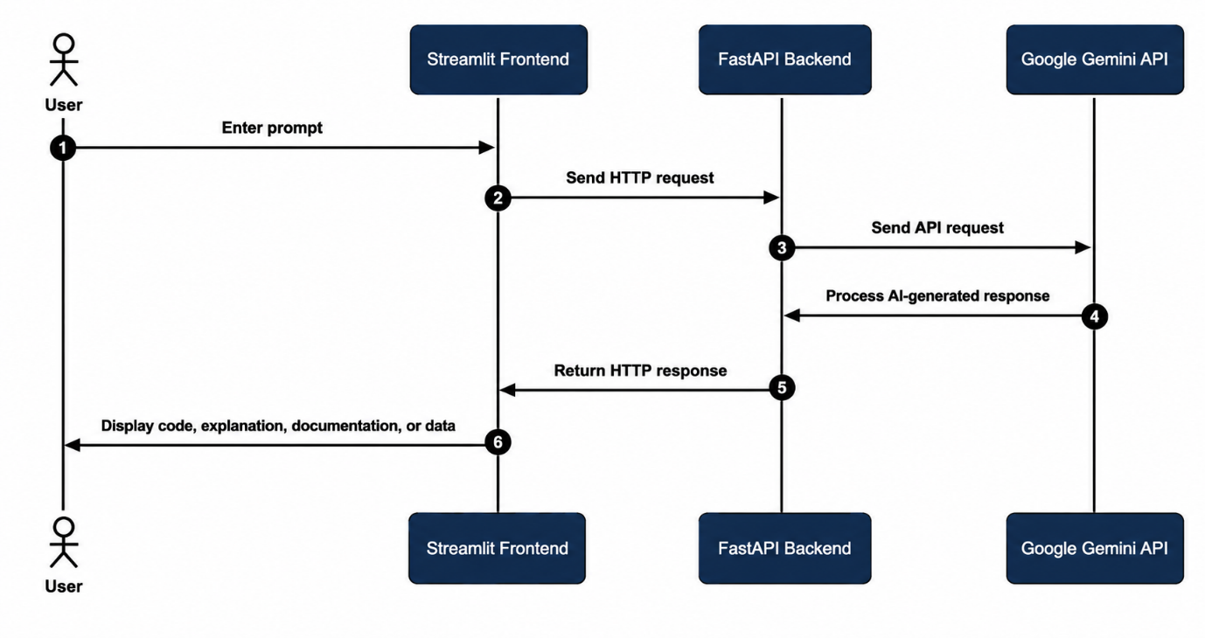

Architecture Description
The application begins when the user enters a programming prompt through the Streamlit-based user interface. The frontend sends the request to the FastAPI backend using HTTP communication.
The FastAPI backend validates the user's request, processes the prompt, and forwards it to the Google Gemini API. The Gemini Large Language Model analyzes the prompt and generates an intelligent response based on the user's requirements.
The generated response is returned to the FastAPI backend, which formats the output and sends it back to the Streamlit frontend. The application then displays the generated code, explanations, debugging suggestions, or documentation to the user in real time.
Key Components
- User: Provides programming-related prompts or queries.
- Streamlit Frontend: Offers an interactive interface for user input and displays AI-generated results.
- FastAPI Backend: Handles request processing, API communication, and response management.
- Google Gemini API: Performs AI-based code generation, debugging, explanation, and documentation tasks.
- Output Module: Displays the final AI-generated content to the user in a structured and readable format.

Advantages of the Architecture
- Modular and scalable design.
- Fast request and response processing.
- Secure communication between frontend and AI services.
- Easy integration of additional AI features.
- Simple maintenance and future enhancements.
- Improved user experience through a responsive interface.
The architecture ensures efficient interaction between the user, backend services, and the AI model, making the application reliable, scalable, and suitable for real-world software development assistance.

Project Workflow
Project Workflow
The Autonomous Coding Agent Using Generative AI follows a systematic workflow to process user requests and generate intelligent responses. The workflow ensures smooth communication between the user interface, backend server, and the Google Gemini API.
Workflow Diagram
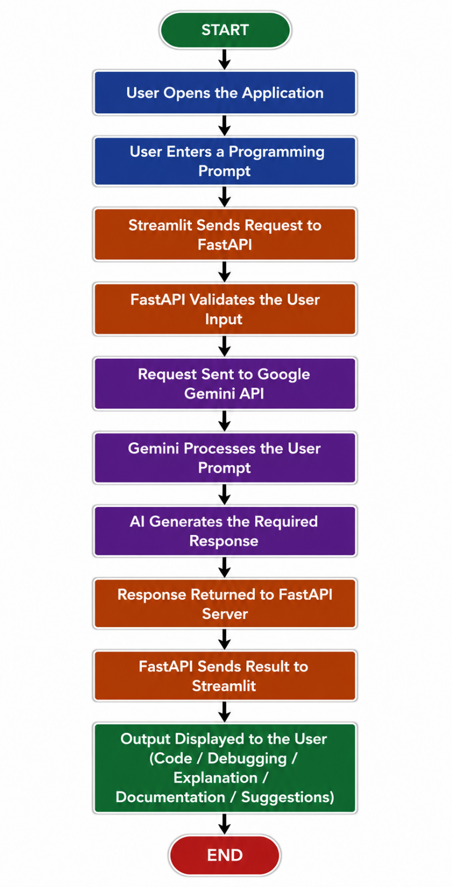

Workflow Description:
Step 1: Launch Application
The user starts the application through the Streamlit interface.
Step 2: Enter Prompt
The user enters a programming-related request in natural language, such as generating code, debugging an error, explaining code, or creating documentation.
Step 3: Request Processing
The Streamlit frontend sends the request to the FastAPI backend using HTTP communication.
Step 4: Input Validation
The FastAPI backend verifies the request, prepares it for processing, and ensures that the input is valid.
Step 5: AI Processing
The validated request is forwarded to the Google Gemini API. The Large Language Model interprets the prompt and generates an intelligent response.
Step 6: Response Generation
Depending on the user's request, the AI may generate:
- Source code
- Code explanation
- Debugging suggestions
- Technical documentation
- Programming guidance
Step 7: Response Delivery
The generated response is sent back to the FastAPI backend, which processes and forwards it to the Streamlit frontend.
Step 8: Display Output
The frontend displays the AI-generated output in a structured and user-friendly format. Users can review, copy, or use the generated content.
Workflow Benefits
- Fast and efficient processing of user requests.
- Accurate AI-powered code generation.
- Easy interaction through a simple user interface.
- Modular communication between frontend, backend, and AI services.
- Scalable architecture for future feature enhancements.
The workflow ensures reliable communication between all components of the application, enabling users to receive high-quality AI-assisted programming support in real time.

Algorithm
Algorithm
The following algorithm describes the working process of the Autonomous Coding Agent Using Generative AI.
Algorithm: Autonomous Coding Agent
Step 1: Start the application.
Step 2: Launch the Streamlit frontend and establish a connection with the FastAPI backend.
Step 3: Wait for the user to enter a programming prompt.
Step 4: Receive the user's input from the Streamlit interface.
Step 5: Validate the input to ensure it is not empty or invalid.
Step 6: Forward the validated prompt to the FastAPI backend.
Step 7: The backend securely sends the request to the Google Gemini API.
Step 8: The Gemini Large Language Model analyzes the prompt and identifies the user's requirements.
Step 9: Generate the appropriate response based on the user's request. The response may include:
- Source code
- Code explanation
- Bug detection and debugging suggestions
- Documentation
- Programming guidance
Step 10: Receive the AI-generated response from the Gemini API.
Step 11: Process and format the response in the FastAPI backend.
Step 12: Send the formatted response to the Streamlit frontend.
Step 13: Display the generated output to the user.
Step 14: Allow the user to submit another prompt if required.
Step 15: Repeat Steps 4 to 14 until the user exits the application.
Step 16: Terminate the application.

Pseudocode
BEGIN

Initialize Streamlit Frontend
Initialize FastAPI Backend
Connect to Google Gemini API

WHILE application is running DO

Receive user prompt

IF prompt is empty THEN
Display validation message
ELSE
Send prompt to FastAPI
Forward prompt to Gemini API
Process AI response
Format response
Display output to user
END IF

END WHILE

Close application

END

Time Complexity
Operation | Complexity
Input Validation | O(1)
API Request | O(1)*
Response Processing | O(n)
Output Display | O(n)
Algorithm Advantages
- Simple and easy to understand.
- Supports multiple programming-related tasks.
- Provides AI-generated responses in real time.
- Reduces manual coding effort.
- Modular design for easy maintenance and future enhancements.
- Can be extended to support additional AI models and features.

The algorithm ensures efficient communication between the user interface, backend services, and the AI model, enabling reliable and intelligent coding assistance throughout the application's execution.

Module Description
Module Description
The Autonomous Coding Agent Using Generative AI is designed using a modular architecture, where each module performs a specific function. This approach improves maintainability, scalability, and overall application performance.
8.1 User Interface Module
The User Interface is developed using Streamlit and serves as the interaction layer between the user and the application. It provides a clean and intuitive environment where users can enter programming prompts, view AI-generated responses, access chat history, and interact with voice features.
Functions:
- Accepts user prompts.
- Displays AI-generated responses.
- Provides an interactive and user-friendly interface.
- Supports navigation and user interaction.
Prompt Processing Module
This module receives user input from the frontend and performs initial validation before forwarding the request to the backend. It ensures that only valid prompts are processed by the AI model.
Functions:
- Receives user prompts.
- Validates user input.
- Removes invalid or empty requests.
- Forwards requests to the backend.
AI Code Generation Module
This is the core module of the application. It communicates with the Google Gemini API to generate source code, explain programming concepts, debug errors, and produce technical documentation based on user prompts.
Functions:
- Generates source code.
- Explains code.
- Fixes programming errors.
- Generates documentation.
- Answers programming-related questions.

Backend API Module
The backend is developed using FastAPI and acts as the communication bridge between the frontend and the Google Gemini API. It processes requests, manages API communication, and returns AI-generated responses.
Functions:
- Receives frontend requests.
- Sends requests to the Gemini API.
- Processes AI responses.
- Returns formatted results to the frontend.

Chat History Module
The Chat History module stores user prompts and AI responses during the session. It allows users to review previous conversations without re-entering prompts.
Functions:
- Stores conversation history.
- Displays previous interactions.
- Maintains session continuity.
- Improves user experience.

Voice Input Module
The Voice Input module allows users to provide programming prompts through speech instead of typing. Spoken input is converted into text before processing.
Functions:
- Captures voice commands.
- Converts speech to text.
- Sends converted text for AI processing.
Voice Output Module
The Voice Output module converts AI-generated responses into speech, making the application more accessible and interactive.
Functions:
- Converts text responses into speech.
- Reads AI-generated explanations.
- Improves accessibility.

Documentation Generator Module
This module automatically generates project documentation and technical descriptions based on user requests. It helps users prepare reports, summaries, and documentation efficiently.
Functions:
- Generates technical documentation.
- Creates project summaries.
- Produces structured documentation content.

Module Interaction
All modules work together in a coordinated manner. The Streamlit User Interface collects user input and passes it to the Prompt Processing Module. The Backend API Module communicates with the Google Gemini API, retrieves AI-generated responses, and sends them back to the frontend. Additional modules such as Chat History, Voice Input, Voice Output, and Documentation Generator enhance the overall functionality and improve the user experience.
The modular design ensures that each component performs a dedicated task while maintaining seamless communication with other modules. This architecture makes the application easier to maintain, upgrade, and extend with new features in the future.

Project Folder Structure
Project Folder Structure
The Autonomous Coding Agent Using Generative AI project follows a modular folder structure that separates the frontend, backend, AI modules, assets, generated files, and configuration files. This organization improves code readability, maintainability, and scalability.
Project Directory Structure
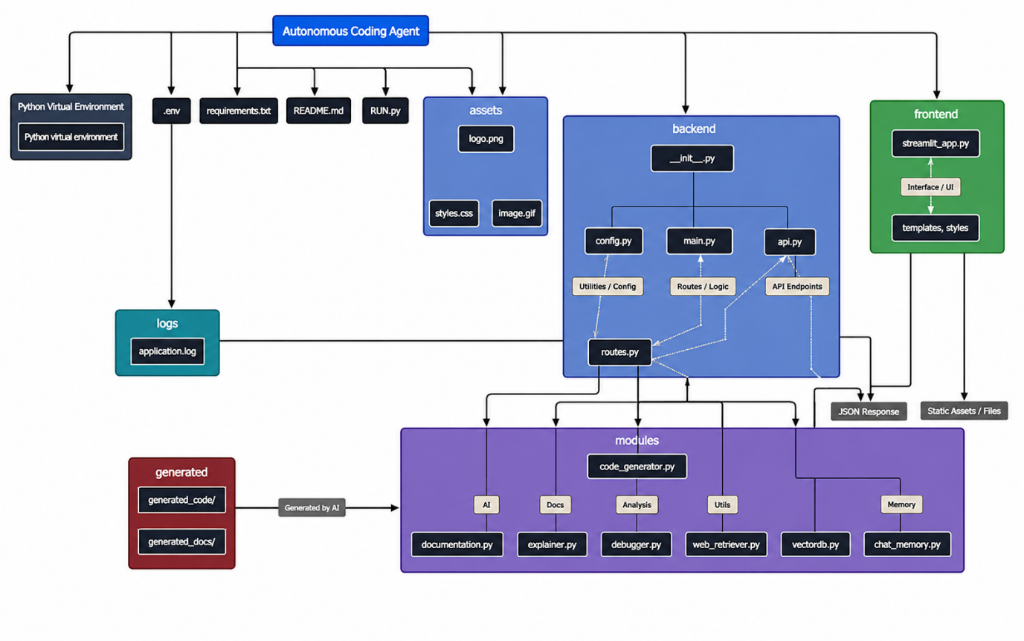

Folder Description
Assets : Stores static resources such as the application logo, images, icons, and styling files used by the frontend.
Backend : Contains the FastAPI application responsible for handling HTTP requests, API routing, configuration, and communication with the Google Gemini API.
Frontend : Contains the Streamlit application that provides the graphical user interface for user interaction.
Modules : Contains the core functional modules of the application, including:
- Code Generation
- Documentation Generation
- Code Explanation
- Debugging
- Voice Input
- Voice Output
- Chat History Management
Generated : Stores AI-generated code files and documentation produced during application execution.
Logs : Maintains application logs that help monitor execution and troubleshoot errors.
Venv : Contains the Python virtual environment and installed project dependencies.
.env : Stores environment variables such as the Google Gemini API key and other configuration settings.
requirements.txt : Lists all Python libraries required to install and run the application.
README.md : Provides project information, installation instructions, and usage guidelines.
run.py : Acts as the main entry point to launch the application.
Advantages of the Folder Structure
- Modular and easy to understand.
- Separates frontend and backend components.
- Improves code maintainability.
- Supports future feature enhancements.
- Simplifies debugging and testing.
- Encourages clean and scalable software development practices.
A well-organized folder structure enables efficient project management, making it easier to develop, maintain, and extend the Autonomous Coding Agent in the future.

Implementation
Implementation
The Autonomous Coding Agent Using Generative AI was implemented using a modular software architecture consisting of a Streamlit frontend, a FastAPI backend, and the Google Gemini API. The application enables users to interact with an AI-powered coding assistant through a simple web interface.
The implementation focuses on providing an efficient workflow where user requests are processed, analyzed by the AI model, and returned as meaningful responses such as source code, debugging suggestions, explanations, and documentation.
Frontend Implementation
The frontend was developed using Streamlit, which provides a lightweight and interactive web interface. Users can enter programming prompts, submit requests, and view AI-generated responses in real time.
Frontend Responsibilities
- Accept user input.
- Display generated code.
- Show debugging suggestions.
- Display documentation.
- Maintain chat history.
- Support voice input and voice output.
Backend Implementation
The backend was developed using FastAPI. It acts as the communication layer between the frontend and the Google Gemini API.
When a user submits a prompt, the backend validates the input, forwards it to the AI model, processes the returned response, and sends the formatted output back to the frontend.
Backend Responsibilities
- Receive frontend requests.
- Validate user input.
- Connect to the Gemini API.
- Process AI responses.
- Return formatted output.

AI Integration
The application integrates the Google Gemini API to perform intelligent programming tasks.
The AI model processes natural language prompts and generates responses such as:
- Source code
- Code explanations
- Error detection
- Debugging suggestions
- Technical documentation
This integration enables the application to function as an intelligent coding assistant.

User Interaction Flow
The implementation follows these steps:
- The user opens the application.
- A programming prompt is entered.
- Streamlit sends the request to FastAPI.
- FastAPI validates the input.
- The request is forwarded to the Google Gemini API.
- Gemini processes the prompt.
- The AI-generated response is returned.
- FastAPI formats the output.
- Streamlit displays the final result.
Error Handling
To improve reliability, the application includes error-handling mechanisms.
These include:
- Empty prompt validation.
- API exception handling.
- Network error handling.
- Invalid response detection.
- User-friendly error messages.
These mechanisms help maintain application stability during execution.
Implementation Benefits
The implementation offers several advantages:
- Modular architecture.
- Fast request processing.
- AI-powered intelligent responses.
- Easy maintenance.
- Scalable design.
- User-friendly interface.
- Efficient API communication.
- Improved developer productivity.
The modular implementation makes the application easy to enhance by adding new AI capabilities, additional programming language support, or advanced development features in future versions.

Features of the System
Features of the System
The Autonomous Coding Agent Using Generative AI is designed to simplify software development by providing AI-powered assistance for programming-related tasks. The application combines modern web technologies with Generative AI to deliver an efficient and interactive coding experience.
AI-Powered Code Generation
The application accepts programming prompts written in natural language and generates source code using the Google Gemini API. It supports code generation for different programming tasks and helps users quickly develop solutions.
Code Explanation
Users can request explanations for source code. The AI provides step-by-step descriptions, making it easier for students and developers to understand programming concepts and logic.
Debugging Assistance
The system helps identify common programming errors and suggests possible corrections. This feature assists users in understanding mistakes and improving code quality.
Documentation Generation
The application can generate technical documentation, project descriptions, and summaries based on user requirements. This reduces the time required to prepare project-related documents.
Interactive User Interface
The Streamlit-based interface is simple, responsive, and easy to use. Users can enter prompts, submit requests, and view AI-generated results without requiring advanced technical knowledge.
Fast API Communication
The FastAPI backend enables efficient communication between the frontend and the Google Gemini API, ensuring quick processing of user requests and smooth response delivery.
Voice Input and Voice Output
The system supports voice-based interaction by allowing users to provide prompts through speech and receive AI-generated responses in audio format, improving accessibility and user experience.
Modular Design
The application follows a modular architecture in which each functional component is organized separately. This improves code readability, simplifies maintenance, and supports future feature expansion.
User-Friendly Experience
The application is designed with simplicity in mind. Users can interact with the AI assistant through an intuitive interface, making the system suitable for beginners as well as experienced developers.
Key Features Summary
Feature | Description
AI Code Generation | Generates source code from natural language prompts
Code Explanation | Explains programming logic in simple language
Debugging Support | Identifies errors and suggests improvements
Documentation Generation | Creates technical documentation automatically
Streamlit Interface | Provides an interactive and responsive frontend
FastAPI Backend | Handles request processing and API communication
Chat History | Maintains previous user interactions
Voice Support | Enables voice input and voice output
Modular Architecture | Improves maintainability and scalability

Benefits of the Features
- Reduces software development time.
- Improves coding efficiency.
- Assists beginners in learning programming concepts.
- Simplifies debugging and documentation.
- Enhances user interaction through an intuitive interface.
- Demonstrates the practical application of Generative AI in software development.
Overall, these features make the Autonomous Coding Agent Using Generative AI an effective and user-friendly solution for AI-assisted software development.

Source Code Implementation
FastAPI Application Initialization
The backend server is developed using FastAPI. It initializes the application, configures middleware, and loads the API routes responsible for handling user requests.
Code Snippet:
from fastapi import FastAPI
from fastapi.middleware.cors import CORSMiddleware
from backend.routes import router

app = FastAPI(
title="Autonomous Coding Agent",
description="AI-powered coding assistant",
version="1.0"
)

app.include_router(router)
Description:
This code initializes the FastAPI application and registers the API routes. It serves as the entry point for all backend requests.

API Route for Code Generation
The application receives the user's programming prompt through a REST API endpoint.
Code Snippet:
from fastapi import APIRouter
from pydantic import BaseModel
from modules.code_generator import generate_code
router = APIRouter()
class PromptRequest(BaseModel):
prompt: str

@router.post("/generate")
def generate(request: PromptRequest):
return {"generated_code": generate_code(request.prompt)}
Description:
This API endpoint accepts a programming prompt from the frontend, processes it using the AI module, and returns the generated response.

Code Generation Module
The Code Generation module communicates with the AI client to generate intelligent programming responses.
Code Snippet:
from backend.ai_client import ask_ai

def generate_code(prompt):
return ask_ai(prompt)
Description:
This function forwards the user's prompt to the AI client and returns the generated response to the backend.

AI Integration
The AI client is responsible for communicating with the Google Gemini API and obtaining AI-generated responses.
Purpose:
- Sends prompts to the AI model.
- Receives generated responses.
- Returns the response to the Code Generation module.

Documentation Module
The Documentation module generates technical documentation based on the user's requirements.
Purpose:
- Creates project documentation.
- Generates summaries.
- Produces structured technical content.

Code Explanation Module
The Code Explanation module helps users understand source code by generating simple explanations.
Purpose:
- Explains program logic.
- Describes functions and algorithms.
- Improves programming understanding.

Prompt Optimization Module
This module improves user prompts before they are processed by the AI model, increasing the quality and relevance of generated responses.

Syntax Checker Module
The Syntax Checker validates generated code and helps identify syntax-related issues before presenting the output.

Helper Functions
The Helper module contains reusable utility functions that simplify common operations across different modules of the application.

Summary
The source code implementation follows a modular architecture. Each module performs a dedicated task while working together to provide an efficient AI-powered coding assistant. This design improves maintainability, scalability, and future extensibility of the application.
Results and Screenshots
Results and Screenshots
The Autonomous Coding Agent Using Generative AI was successfully designed and implemented using Python, Streamlit, FastAPI, and the Google Gemini API. The application performs AI-assisted programming tasks efficiently by accepting user prompts and generating intelligent responses in real time.
The testing results demonstrate that the system can generate source code, explain programming concepts, assist with debugging, and produce technical documentation through a simple and interactive user interface.

Home Page
Screenshot:
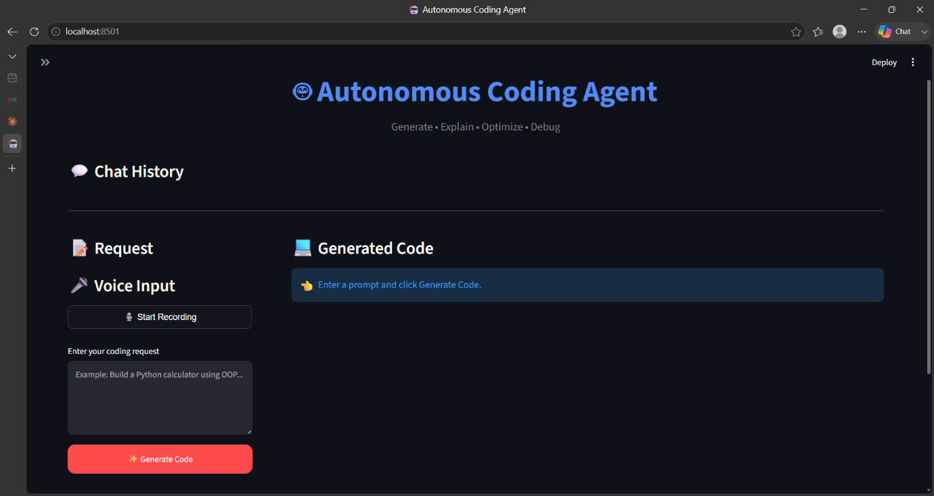

Description:
The home page provides the main user interface where users can enter programming prompts, access available features, and interact with the AI coding assistant.

Code Generation
Screenshot: 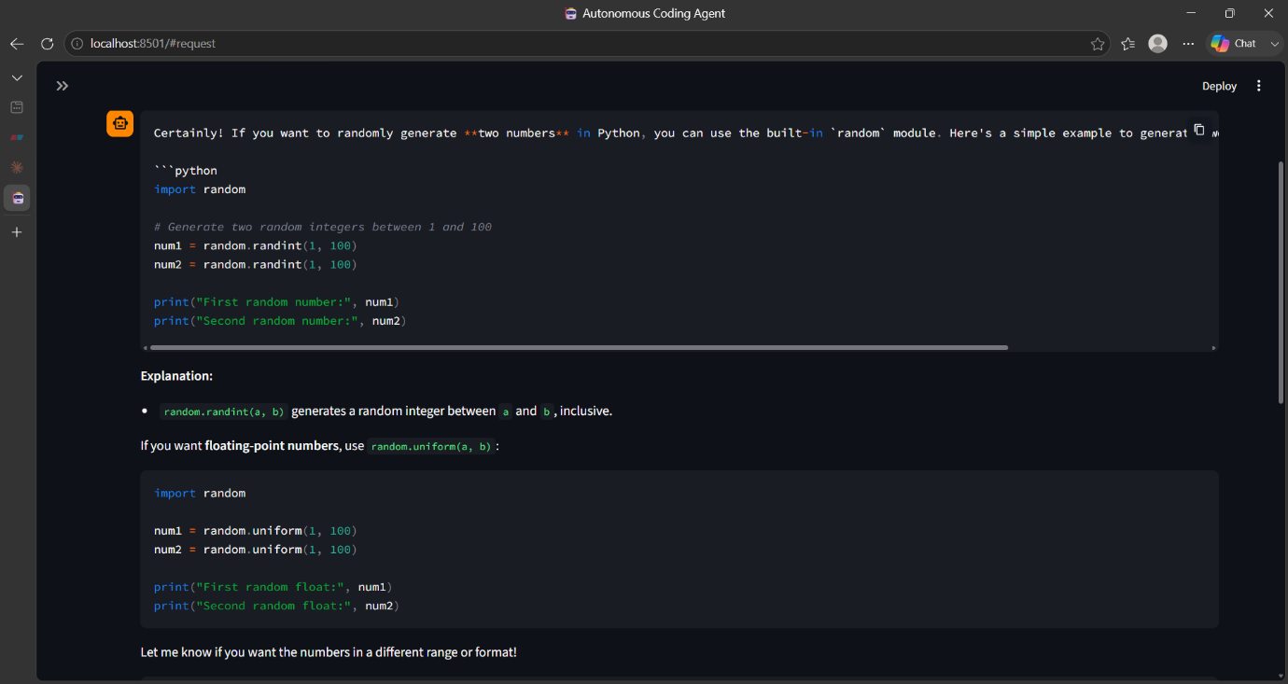

Description:
The application successfully generates source code based on the user's natural language prompt. The generated code is displayed instantly in a structured and readable format.

Code Explanation
Screenshot 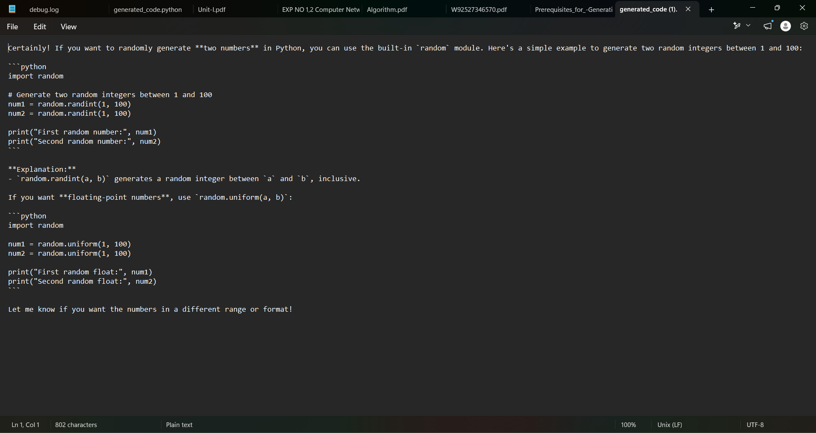

Description:
The AI explains the generated source code step by step, helping users understand the logic, syntax, and functionality of the program.
Documentation Generation
Screenshot
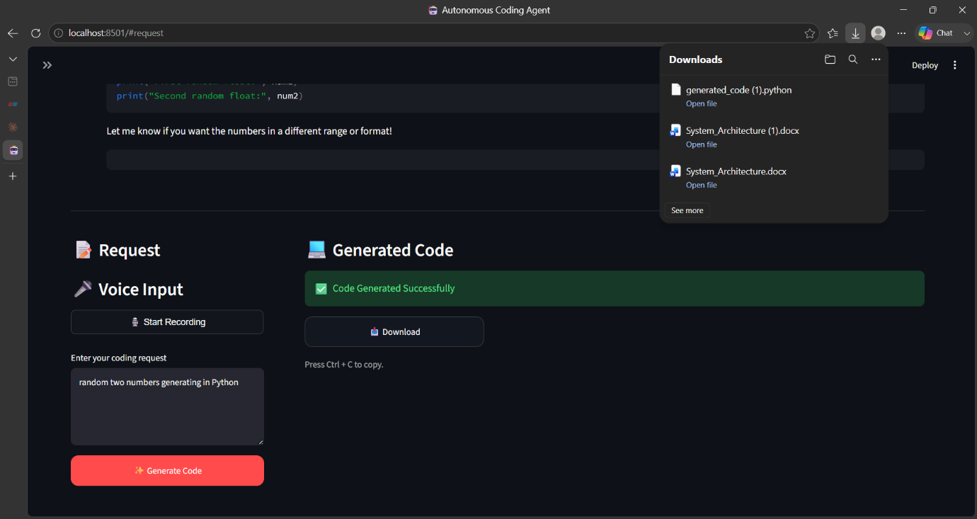


Description:
The Documentation Generator creates project documentation, summaries, or technical descriptions according to the user's request.

Voice Interaction
Screenshot 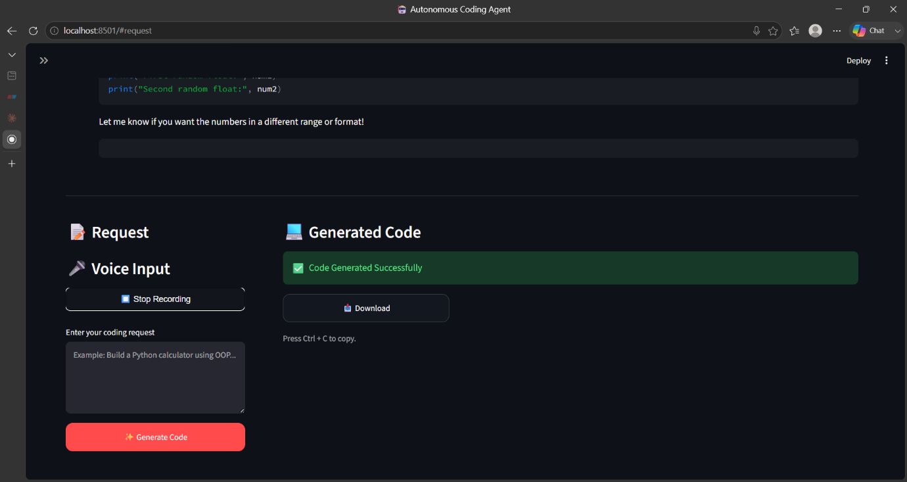

Description:
The Voice Interaction module enables users to communicate with the application using speech, improving accessibility and user convenience.

Chat History
Screenshot: 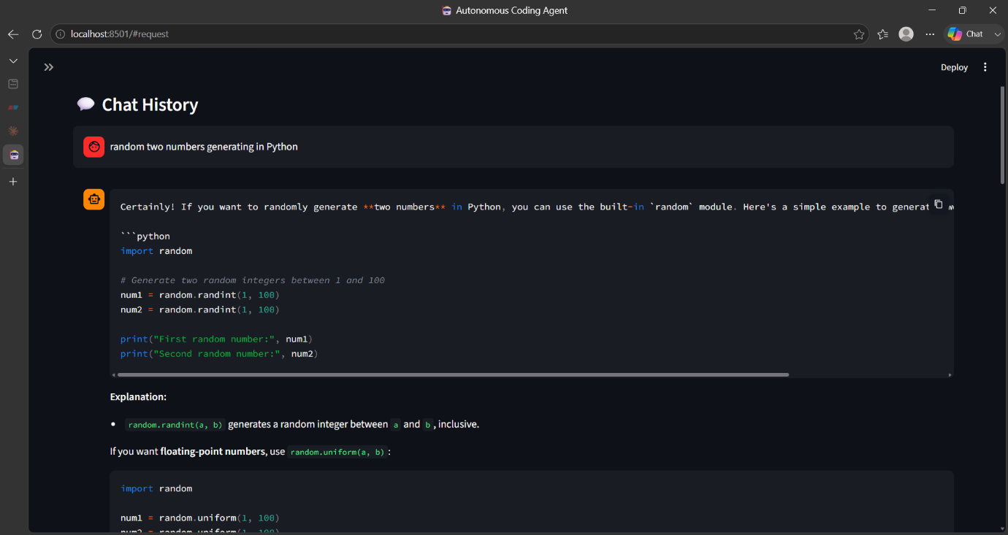

Description:
The Chat History module stores previous prompts and responses within the current session, allowing users to review earlier interactions.
Overall Results
The project was successfully tested under different programming scenarios. The application demonstrated reliable performance by generating accurate responses for code generation, debugging, explanation, and documentation tasks.

Project Outcomes
Functionality | Status
User Interface | ✓ Successfully Implemented
Prompt Processing | ✓ Successfully Implemented
AI Code Generation | ✓ Successfully Implemented
Code Explanation | ✓ Successfully Implemented
Documentation Generation | ✓ Successfully Implemented
Debugging Support | ✓ Successfully Implemented
Chat History | ✓ Successfully Implemented
Voice Features | ✓ Successfully Implemented
FastAPI Integration | ✓ Successfully Implemented
Google Gemini API Integration | ✓ Successfully Implemented
The successful implementation and testing of all major modules demonstrate that the Autonomous Coding Agent Using Generative AI effectively fulfills its objective of providing AI-assisted programming support. The project highlights the practical use of Generative AI in modern software development and offers an intuitive solution for developers, students, and programming enthusiasts.

Challenges Faced
During the development of the Autonomous Coding Agent Using Generative AI, several technical and implementation challenges were encountered. These challenges provided valuable learning opportunities and improved my understanding of AI integration, backend development, and software debugging.

Google Gemini API Integration
Integrating the Google Gemini API with the FastAPI backend required proper API configuration, authentication, and request handling. Initially, incorrect API configurations and authentication issues prevented successful communication with the AI model.
Solution:
- Configured the API key correctly using environment variables.
- Verified API requests and responses.
- Implemented proper exception handling to manage API-related errors.

Backend and Frontend Communication
Establishing seamless communication between the Streamlit frontend and the FastAPI backend required proper endpoint configuration and request handling.
Solution:
- Configured REST API endpoints correctly.
- Tested API communication using local server requests.
- Validated request and response formats to ensure successful data exchange.

Error Handling
Unexpected situations such as invalid input, empty prompts, and API failures affected application stability during testing.
Solution:
- Added input validation.
- Implemented exception handling using Python.
- Displayed user-friendly error messages for better usability.

Prompt Optimization
Different prompt formats produced different AI responses. Poorly structured prompts occasionally resulted in incomplete or less accurate outputs.
Solution:
- Improved prompt structure.
- Tested multiple prompt formats.
- Used clear and descriptive instructions to obtain more accurate responses.
Debugging Application Errors
During development, runtime errors and configuration issues occasionally interrupted application execution.
Solution:
- Used Visual Studio Code debugging tools.
- Analyzed error logs.
- Tested individual modules before integrating the complete system.
User Interface Design
Creating a simple yet effective user interface required balancing usability and functionality while keeping the application responsive.
Solution:
- Designed a clean Streamlit interface.
- Organized application components logically.
- Improved layout and readability through iterative testing.
Learning New Technologies
The project involved learning several new technologies, including Streamlit, FastAPI, Google Gemini API integration, and Generative AI concepts.
Solution:
- Studied official documentation.
- Practiced implementing small examples.
- Gradually integrated each technology into the project.

Challenges Summary
Challenge | Solution
Google Gemini API Integration | Configured API keys and implemented proper request handling
Frontend-Backend Communication | Developed REST API endpoints using FastAPI
Error Handling | Added validation and exception handling
Prompt Optimization | Improved prompt engineering techniques
Debugging | Used debugging tools and tested modules individually
User Interface | Developed an intuitive Streamlit interface
Learning New Technologies | Studied documentation and practiced implementation

Learning Outcomes
Overcoming these challenges significantly improved my technical knowledge and practical development skills. The project enhanced my understanding of:
- Generative AI application development.
- Google Gemini API integration.
- FastAPI backend development.
- Streamlit frontend development.
- API communication and debugging.
- Prompt engineering techniques.
- Software testing and troubleshooting.
- Modular software design.
These experiences strengthened my confidence in building AI-powered applications and provided valuable hands-on exposure to real-world software development practices.

Future Enhancements
The Autonomous Coding Agent Using Generative AI has been successfully developed to provide AI-powered coding assistance. Although the current version offers features such as code generation, debugging support, documentation generation, code explanation, and voice interaction, there are several opportunities to further improve the application in future versions.

Support for Multiple AI Models
The current system uses the Google Gemini API. Future versions can be enhanced by integrating multiple AI models such as OpenAI GPT, Anthropic Claude, or open-source Large Language Models (LLMs). This would allow users to compare responses and choose the most suitable AI model for their requirements.

User Authentication and Profile Management
A secure user authentication system can be implemented to allow users to create personal accounts, manage their profiles, and securely access their coding history and saved projects.
Benefits:
- Secure login system
- Personalized user experience
- Saved chat history
- User-specific settings

Database Integration
Currently, the application mainly processes requests during execution. Future versions can integrate databases such as MySQL or MongoDB to store user information, project history, generated code, and documentation for future reference.

Support for More Programming Languages
The application can be extended to provide improved support for a wider range of programming languages, including:
- Java
- Python
- C
- C++
- JavaScript
- PHP
- SQL
- Go
- Rust
- Kotlin
- Swift
This enhancement would make the application useful for a broader developer community.
Cloud Deployment
The application can be deployed on cloud platforms such as Google Cloud, Microsoft Azure, or Amazon Web Services (AWS). Cloud deployment would improve accessibility, scalability, and availability, allowing users to access the system from anywhere.

Intelligent Code Review
Future versions can include an automated code review system that evaluates code quality, identifies inefficient logic, detects security vulnerabilities, and suggests best coding practices.
Project Generation
The application can be enhanced to generate complete project structures, including:
- Source code
- Folder organization
- Configuration files
- Documentation
- Test cases
This would significantly reduce project development time.

Team Collaboration Features
Future versions may include collaboration features that allow multiple developers to work on the same project, share generated code, and review changes in real time.

Mobile Application
Developing an Android and iOS application would allow users to access the AI coding assistant from smartphones and tablets, improving flexibility and accessibility.

Offline AI Support
Future improvements may include support for locally hosted AI models, enabling users to access coding assistance without an internet connection. This would improve privacy and reduce dependence on external APIs.

Future Enhancement Summary
Enhancement | Expected Benefit
Multiple AI Models | Improved response quality and flexibility
User Authentication | Secure and personalized access
Database Integration | Persistent storage of user data and project history
Additional Programming Languages | Wider usability across different technologies
Cloud Deployment | Global accessibility and scalability
Intelligent Code Review | Improved code quality and security
Complete Project Generation | Faster software development
Team Collaboration | Better collaboration among developers
Mobile Application | Anywhere, anytime access
Offline AI Support | Reduced internet dependency and enhanced privacy

Conclusion
The Autonomous Coding Agent Using Generative AI was successfully designed and developed as an individual internship project during the Generative AI Internship at Blackbucks. The primary objective of the project was to create an intelligent coding assistant capable of understanding natural language prompts and providing AI-powered programming assistance.
The application integrates Python, Streamlit, FastAPI, and the Google Gemini API to deliver features such as source code generation, code explanation, debugging assistance, documentation generation, chat history, and voice interaction. These features help simplify software development by reducing manual effort and improving coding efficiency.
Throughout the development process, several technical challenges were encountered, including API integration, backend communication, error handling, and prompt optimization. These challenges were successfully addressed through research, testing, debugging, and continuous improvement, resulting in a stable and functional application.
This internship project provided valuable hands-on experience in Generative AI, API integration, backend development, frontend development, prompt engineering, and software testing. It also strengthened my problem-solving abilities and enhanced my understanding of building AI-powered applications using modern technologies.
The project demonstrates the practical application of Large Language Models (LLMs) in software development and highlights how Artificial Intelligence can improve developer productivity and simplify programming tasks. The modular architecture of the application also makes it suitable for future enhancements and feature expansion.
Overall, the Autonomous Coding Agent Using Generative AI successfully achieved its objectives and represents a meaningful learning experience during the internship. It has strengthened my technical knowledge, improved my software development skills, and provided practical exposure to developing real-world AI applications.

References
The following references were used during the design, development, and implementation of the Autonomous Coding Agent Using Generative AI project.
Books
- Ian Goodfellow, Yoshua Bengio, and Aaron Courville, Deep Learning, MIT Press, 2016.
- Stuart Russell and Peter Norvig, Artificial Intelligence: A Modern Approach, 4th Edition, Pearson Education, 2021.
- Eric Matthes, Python Crash Course, 3rd Edition, No Starch Press, 2023.
Official Documentation
- Python Software Foundation. Python Documentation. Available at: https://docs.python.org/3/
- Streamlit Inc. Streamlit Documentation. Available at: https://docs.streamlit.io/
- FastAPI. FastAPI Documentation. Available at: https://fastapi.tiangolo.com/
- Google AI. Gemini API Documentation. Available at: https://ai.google.dev/
- Git Documentation. Available at: https://git-scm.com/doc
- GitHub Documentation. Available at: https://docs.github.com/
Development Tools
- Visual Studio Code
- Git
- GitHub
- Python 3.x
- Streamlit
- FastAPI
- Google Gemini API
Online Resources
- Stack Overflow – https://stackoverflow.com/
- GeeksforGeeks – https://www.geeksforgeeks.org/
- MDN Web Docs – https://developer.mozilla.org/
Research Papers and Articles
Various articles and technical blogs related to:
- Generative AI
- Large Language Models (LLMs)
- Prompt Engineering
- AI-assisted Software Development
- REST API Development
- Python Application Development
These resources helped in understanding the concepts and implementing the project successfully.

